**Project Bloom: A Quest for Home**

Developed By:

Renegadeware

Version 1.0.0

# 

# Table of Contents

Contents

Table of Contents 1

Game Overview 4

Target Learning Objective (LO) 4

Demographics - Target Audience 4

Genre / Theme / Setting 4

Core Gameplay Summary 4

Look and Feel 6

Target Platform(s) 7

Game Flow 8

Overworld 8

Summary 8

Mechanics 11

Losing Gameplay / Incorrect Concept Understanding 11

Colony Sim 12

Summary 12

Mechanics 16

Losing Gameplay / Incorrect Concept Understanding 16

Part 1 – Temperate Climate (Summer) Overworld 16

L.O. Concepts Covered 16

Summary 16

Part 2 – Temperate Climate (Summer) Colony Sim 17

L.O. Concepts Covered 17

Summary 17

Part 3 – Oceanic Climate Overworld 17

L.O. Concepts Covered 17

Summary 18

Part 4 – Oceanic Climate Colony Sim 18

L.O. Concepts Covered 18

Summary 19

Part 5 – Arid Climate Overworld 19

Summary 19

Part 6 – Arid Climate Colony Sim 19

L.O. Concepts Covered 19

Summary 20

Part 7 – Alpine Climate Overworld 20

L.O. Concepts Covered 20

Summary 20

Part 8 – Alpine Climate Colony Sim 20

Summary 21

LO Concept Coverage 22

Academic Concepts 22

Legends of Learning Required Content Practices 23

Checklist Overview 23

Connection Between Gameplay and Learning 25

Role of Text in Learning 25

Characters - Diversity 25

Technical 26

Development Hardware/Software 26

Asset Summary 26

Music and Sounds 26

Art Style 27

Gameplay 27

Specialist Frogs 27

Schedule for Development + Delivery 28

Story / Narrative 28

Back Story 28

Plot Elements 28

# Game Overview

### Target Learning Objective (LO)

* [MS-ESS2.D-1](https://drive.google.com/file/d/1p5Yk3JNJUejWAimRI4LFcppuIQZPLdJZ/view)

### Demographics - Target Audience

* Ages 11-14 (Middle School)

### Genre / Theme / Setting

* Colony Sim – The player is tasked to populate, and sustain a population in regions of various climates.
* Frogs – These critters are chosen as the characters due to their ability to thrive in various climates where a fine balance is maintained. They also indicate the health of an ecosystem: where there are frogs, the ecology is in good condition. Frogs are also known to have some form of social structure, which fits into this game’s genre.
* Earth – The game takes place on Earth. This will help students see a connection into the real world with the lessons. Although there will be some liberties to exaggerate/simplify the weather for gameplay purposes.

### Core Gameplay Summary

The game consists of two parts: Overworld and Colony Sim. The Overworld will consist of finding a suitable place for the frogs to inhabit. Once a suitable place is found, the colony ship will land, and the Colony Sim gameplay begins. The Colony Sim will last for a fixed duration. Afterwards, the game will continue with another colony ship to find a place to land with a different preference. Once all colony ships have landed, the game is complete.

#### Overworld

In the Overworld gameplay, the player is tasked to find a suitable region on Earth for a colony of frogs to inhabit. These frogs will be arriving via a colony ship.

Each colony of frogs will have a set of climate preferences for them to be able to inhabit. These preferences can be: temperature range, humidity range, wind strength, etc. Along with these preferences, their pigment color can also help summarize this at a glance (e.g., green frogs prefer temperate or tropic).

On the Earth’s map, there will be 4 hotspots the player can choose from. Information about the climate preference will also be shown to help as a general guide. Overlay toggles are available to show the Earth’s attributes: temperature, wind, humidity.

When the player clicks on one of the hotspots, a more elaborate detail will be displayed for the region. From here, the player can adjust two things: landing area and timeframe.

The landing area adjustment is essentially where the player chooses the altitude of an area (also factor in biomes). Adjusting this will update the general atmospheric attributes, demonstrating how certain areas (altitude/biome) can change the weather pattern.

The timeframe (seasons) adjustment determines the Colony Sim gameplay’s starting and ending time. This will also update the general atmospheric attributes, indicating the change of weather pattern based on time.

As the player is adjusting the landing area and timeframe, 5 frogs are displayed depicting their mood based on the decision: happy, neutral, sad. This determines if the time and place is ideal. The player must at least have 3 happy frogs. A hint system will give advice as to what the ideal adjustments should be (and also if the player should pick another hotspot).

If all conditions are met (at least 3 happy frogs), the player can click on “Launch” and commence the Colony Sim gameplay.

#### Colony Sim

In the Colony Sim gameplay, the player is tasked to maintain the frogs’ ideal conditions: temperature, humidity, water, food. Maintaining these conditions will allow the population to increase, and vice-versa. After the gameplay ends, the player’s performance is dictated by the number of populations they were able to reach.

The player can build structures to help maintain these attributes. Each structure will however require certain resource, along with maintenance in order for them to function (e.g., agricultural structures require fresh water source, such as a well). Some of these resources can also be found naturally.

Along with structures, the player can assign roles for specialist frogs to help build, maintain, and manipulate the environment (e.g., structures can only be built/maintained if there is at least one engineer). These frogs can be reassigned to another role anytime.

The first structure the player must place is a house, which will start with one population. Each house has a capacity of 5. Afterwards, the player can build structures around to help increase the population. The game will give hints as time progresses.

Certain weather events can cause damages to the structures (e.g., hurricane, high-tide, sandstorm). This can be mitigated by building certain structures, or simply allow engineers to repair them after the catastrophic event. Both cases have its pros/cons (e.g., structures waste spaces and resources).

Along with weather events, there are also wild inhabitants to deal with. These are for the most part can be handled by an assigned specialist frog.

### Look and Feel

* Simplified map of Earth – Emphasis on land outlines, ocean currents, and terrain heights.
* Earth Map Overlays – The game will simulate the overlay view of the Earth’s attributes. These will be simplified to make it clearer for the students on how they function (e.g., wind motions will mostly follow the prevailing winds).
* Backgrounds – Silhouette/shape of the topography/biome of the region, allow for change of color based on weather condition. Also show the sun/moon for each cycle.
* Weather – The game will show just enough details to indicate the current weather: rain, clouds, fog, etc.
* Structures – Each structure will have a symbol on them to indicate their functionality: energy, water, house. Along with the symbol, any form of state/vitality will also be shown (e.g., water amount, population count).
* Frogs – The frogs will have a palette based on their preferred climate (e.g., green = temperate, tan = desert). To distinguish their role, they will be wearing a hat specific to their work (e.g., engineer = hard hat). Though not very frog-like, they will stand upright to show their actions more clearly. However, they will still do their hopping as they move about.

#### Art References

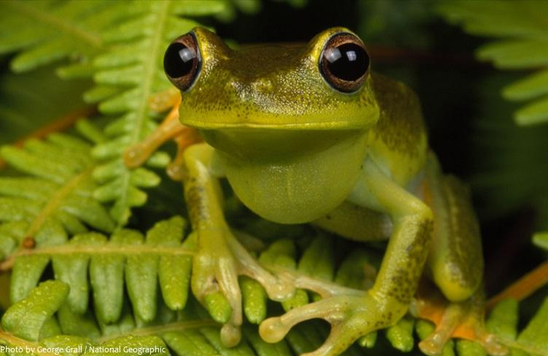 Frog

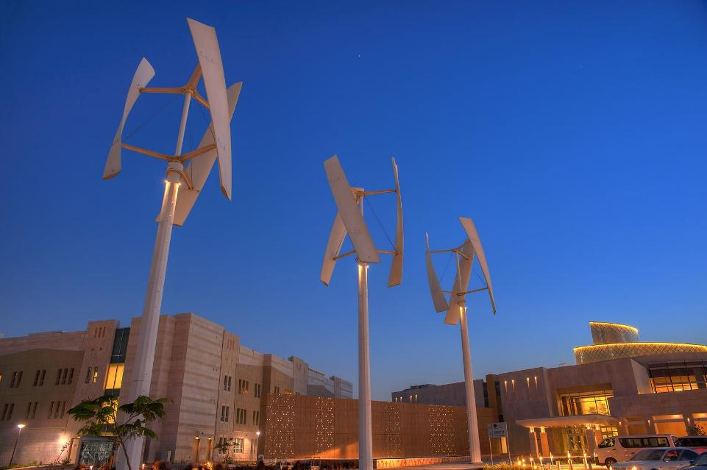 Wind Turbines

### Target Platform(s)

* WebGL with iPad support – Since the game is completely mouse driven, there should be no issue with playing the game in any platform that supports mouse or touch input.

# Game Flow

## Overworld

### Summary

#### Hotspot Selection

* A display of criteria is shown to determine what the frog colony is looking for to inhabit. There are 3 criteria to satisfy:
  + Temperature range
  + Humidity range
  + Wind strength range
* To help the player evaluate these criteria, there are overlay toggles that show the Earth’s atmospheric attribute:
  + Temperature
  + Humidity
  + Wind Strength
* A wind particle animation is also displayed on the map to show how these atmospheric attributes are influenced.
* The player is presented with 4 hotspots to choose from. Selecting one will zoom the map to the location for further investigation.

##### Hotspot Selection Mockup

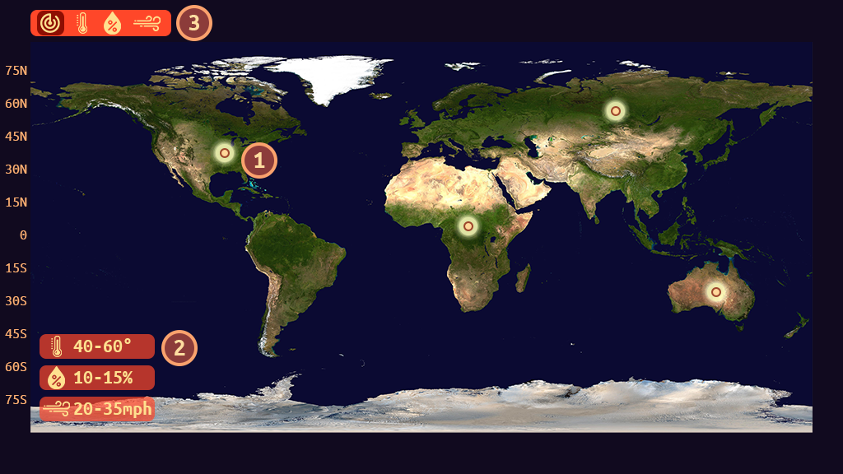

| 1 - Hotspot | 2 – Criteria |
| --- | --- |
| 3 – Overlay Control |  |

##### Temperature Overlay Mockup

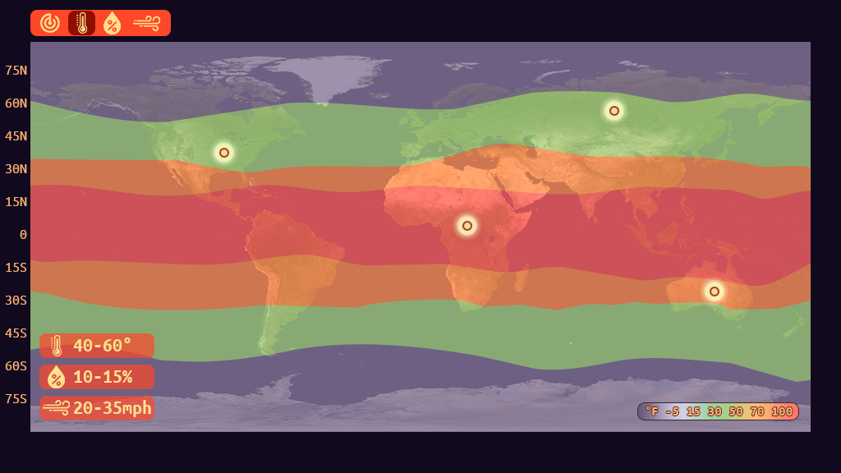

##### Humidity Overlay Mockup

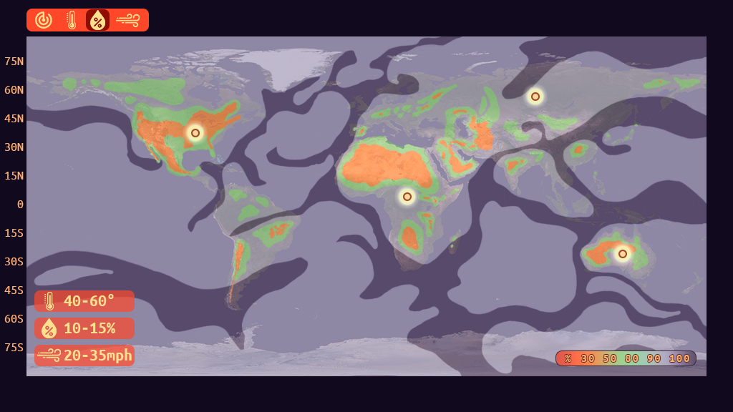

##### Wind Strength Overlay Mockup

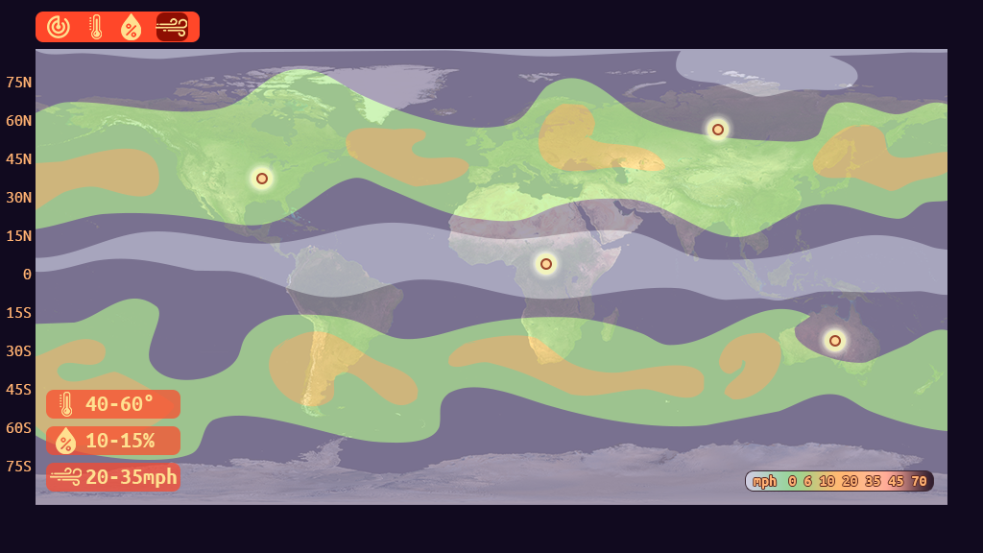

#### Hotspot Investigation

* Upon selecting a hotspot, the view will zoom into its general area.
* From here, information regarding the region’s atmospheric attributes is displayed:
  + Temperature range.
  + Humidity range.
  + Wind strength.
  + Precipitation chance (possibly)
  + Hazard warning
* The player can adjust the location of the landing site via the region slider. This will affect the atmospheric attributes. Altitude is also displayed to show its relation to how the atmosphere is changed. Other than the altitude, the biosphere of the location can also affect the atmosphere.
* The time range can also be adjusted, which is depicted by seasons. (Note: Game will describe seasons as Earth’s position relative to the sun [equinox and solstice]. Also, the difference between meteorological vs. astronomical season). This will also update the atmospheric attribute (as well as the landing site graphical preview, if possible).
* As the player adjusts the landing site, and the time range, frogs will display their approval: happy, neutral, sad.
  + The player must have at least 3 happy frogs to launch the expedition.
* Player can back out at any time if none of the adjustments are of satisfactory.
* Once the player has most approvals, they can launch the expedition. Attempting to launch will simply activate the hint system.
* The hint system will suggest to the player what the sad frogs are looking for (e.g., low temperature, etc.).

##### Hotspot Investigation Mockup

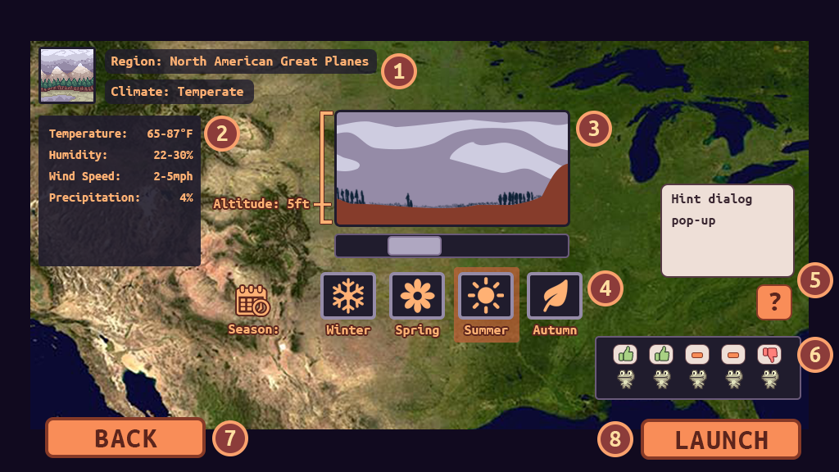

| 1 – Region Details | 2 – Atmospheric Attributes |
| --- | --- |
| 3 – Landing Site Slider | 4 – Timeline Selector |
| 5 – Hint System | 6 – Frog Approvals |
| 7 – Return to Hotspot selection | 8 – Start Colony Sim |

### Mechanics

* The game will be fully controlled via mouse or touch (iPad).
* All inputs are done by simply clicking on the widgets. A highlight for these widgets will appear on mouse hover, or if they are selected.
* Dragging is done when adjusting the Landing Site location via a slider.

### Losing Gameplay / Incorrect Concept Understanding

* There is no losing per-se during this part, only a restriction for launching the colony ship.
* The frog approvals will help the player understand what the requirements are. This allows investigation of how location/time affects the atmospheric attributes.
* Along with the frog approvals, the hint system can be accessed to give hints on what to look for by understanding the atmospheric attributes (e.g., “Look for an area with trees to increase humidity).

## Colony Sim

### Summary

* Colony ship lands, and the weather forecast is displayed. The player can examine each weather type closely from here. Once they are ready, they can click on “OK” to start the game.
* As time moves forward, weather will change as forecasted. The background will have a visual representation of the current weather.
* Each “day” is considered a cycle. The game will have ~7 days/cycles for the entire duration (~2 minutes). These can be adjusted when tweaking the game.
* The atmospheric measurements can be seen at all times at the corner of the screen. When an incoming hazard is about to happen (1-2 cycles away), an indicator will be displayed. Clicking on it will give further description of the hazard in question.
* The player is tasked to populate the region. To do this, they first need to build a house. Each house will have a maximum capacity of 5 frogs (note: can be adjust when tweaking the game). There is a maximum amount of houses the player can place (adjust as needed). (note: could also have the player upgrade the house, and each new upgrade adds a new attribute to satisfy)
* A house requires certain things to increase its population:
  + Temperature
  + Humidity
  + Food
  + Water
* When a requirement is not met, a popup with an icon that represents what is lacking will show on top of the house.
* Population increases/decreases each cycle. If all requirements are met, the population of a house will increase. If 2 requirements are not met, it will decrease (note: tweak if needed).
* To help with the requirements, the player can build structures to manipulate the environment. Some of these structures, however, will require energy or water. A balance must be made.
* Certain structures will be different based on the region (or based on the colony ship). Some structures will also only be available in some regions.
* The following are the structures available for construction (rough idea):
  + Power: wind turbine, solar panel, hydropower, coal power station. Each power has a capacity and charging rate. Any structures that require power will reduce the charge rate (can be negative). Some power structure will require certain environmental condition: strong wind, sunny, etc.
  + Water: well, water tank, saltwater converter. Just like power, water has a charge rate, and this charge rate is consumed by each house. And just like power structures, some will require certain environmental condition: rain, ocean tide level.
  + Heat Generator – place next to/near house. (Note: may just be a house upgrade)
  + A/C Unit – place next to/near house. (Note: may just be a house upgrade)
  + Bunker – for hazardous weather. Each bunker can hold 10 frogs (adjust as needed).
* To place a structure, the player clicks on the “structure” tab at the bottom, then click on the icon that represents the structure they want (e.g., thunder = power, a label will also be shown). Once a structure is selected, a ghost preview of the structure is shown on the landscape. The player can hover the mouse around to determine its placement. If it’s valid, the ghost tint will be green, otherwise it will be red. Clicking on a valid spot will give the player a confirmation by a pop-up. Once confirmed, the structure is placed it as “under construction”. Cancelling will stop the entire placement process (player needs to click on the structure again to place). At least one engineer must be available to build the structure. More engineers will build it faster.
* If the player wants to move the structure, or demolish it, they can click on the structure, and an action context will popup. Moving the structure will be similar to placing it, clicking on an invalid spot will cancel the move action. Just like placement, a confirmation is shown. Once confirmed, an engineering queue will be placed for: deconstruct previous structure, construct same structure to a new location. Clicking on demolish will simply queue the building for demolish.
* Along with structures, the player can choose roles for a number of specialist frogs. The capacity for specialists starts with 1, increased by 1 per house.
* The following are the roles the frogs can be assigned to. And just like structures, some of them will only be available in certain regions (rough idea):
  + Engineer – the game starts with one frog assigned to this. They are responsible for: building, demolishing, repair of structures.
  + Farmer – they grow a “sunflower” near each house. There is a limit of one “sunflower” per household.
  + Forester – they grow trees around the landscape. These trees help with increasing humidity of the region. The more assigned to this, the more trees are planted. They will need a source of water to plant trees.
  + Medic – tend to wounded frogs. Frogs are wounded if they are attacked by pests, harmed by weeds/mushrooms, or by hazardous weather.
  + Pest Control – attacks pests, weeds, mushrooms, etc.
* Specialist frogs reside in the colony ship, and as they are assigned/reassigned, they will emerge from it.
* To deploy specialist frogs, the player clicks on the “frogs” tab at the bottom, then click on an existing frog slot or empty slot. From there, a popup will display a list of specialists. The player can then click on one of the specialists to reassign/assign the role. The player can click outside the list to cancel this process.
* Harmful entities in the region will come in different forms:
  + Pests
    - Fly – flies around menacingly. Can get caught in a wind turbine, causing damage. They also eat “sunflowers”.
    - Hopper – hops around, injuring any frogs it touches.
    - Ground Critter – damages structures in its path as it moves across the landscape.
  + Flora
    - Weed – grows on “sunflowers”, and eats it away.
    - Mushroom – grows randomly around the landscape, destroying “sunflowers” and injuring frogs in contact.
    - Vine – gradually grows on structures, eventually damaging it.
* During hazard weather, the frogs will take shelter. Hazards will cause damages to some structures as it progresses. Some frogs that took shelter in houses will get injured.
* Injured frogs will disappear (or return disappointingly to the colony ship) after a certain duration if they are not healed by a medic. In the case of specialists, they will be removed from their assignment.
* Frogs will come out of the house from time to time to wander around. This is mostly an aesthetic to signify a thriving population (though they can be injured by harmful entities).
* Hint System – the hint system is accessed through an icon at the side of the screen, it’ll show up whenever there’s something the player ought to know or do (e.g., houses lacking food, water, power, etc.). This is also congruent with the pop-up icon that shows on structures that lack resources.
* Fast Forward – if needed/possible, we can add a fast forward feature. Will of course be disabled when there’s a hazard event, or certain actions need to take place. This will also allow us to increase the cycle duration to give players more leeway.
* Once all the cycles have ended, if the population requirement is not met (at least 4, can be adjusted later), the cycle will reset until the player is able to raise the population to minimum (hazards will no longer be triggered). The hint system will guide the player all the way through.
* After the population requirement is met, time will move forward to noon, where the sun is at its summit. All the frogs will gather around the colony ship to celebrate. Rays of sunshine, and special FX will play to emphasize this victory.
* The victory modal will give the player a summary of their performance. This will be based on population count. Other things to consider: population growth graph.

##### Colony Sims Mockups

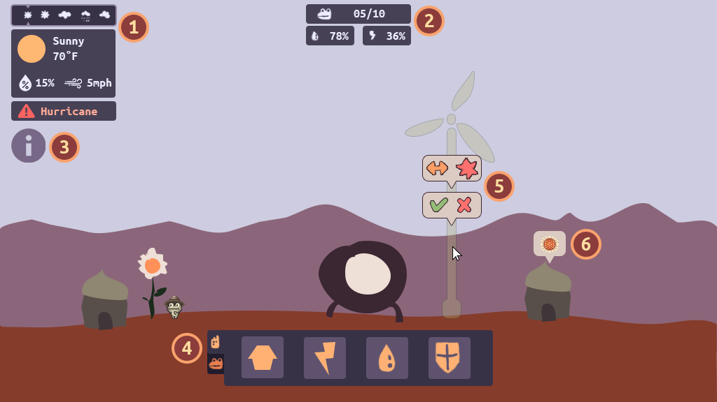

| 1 – Weather Reading/Forecast/Hazzard Warning | 2 – Colony Info (population, water, power) |
| --- | --- |
| 3 – Hint System | 4 – Structures/Roles Palette |
| 5 – Structure Confirmations: build confirm, move/demolish | 6 – House needs icon pop-up. |

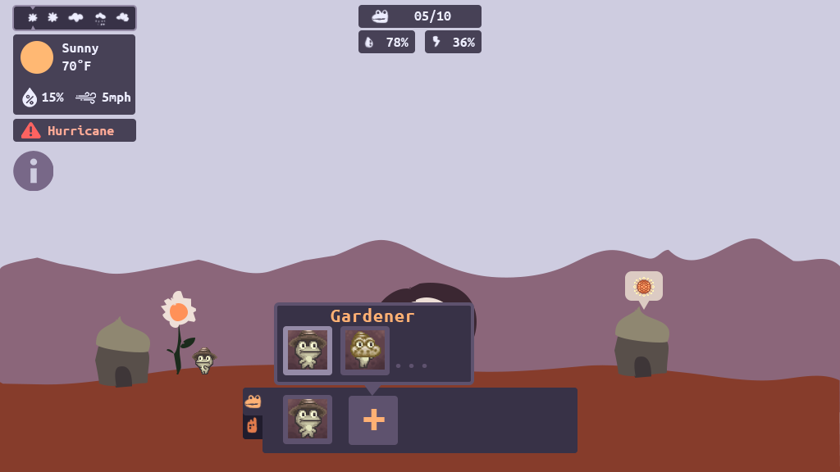

### Mechanics

* The game will be fully controlled via mouse or touch (iPad).
* All inputs are done by simply clicking on the widgets. A highlight for these widgets will appear on mouse hover, or if they are selected.

### Losing Gameplay / Incorrect Concept Understanding

* There is no losing condition during Colony Sims. The player’s performance is simply rated at the end based on population count. If the population requirement is not met, the cycle will reset. The hint system will guide the player to reach this requirement.
* The hint system will guide the player throughout on how to grow/sustain the population.
* The house requirements to grow the population is tied to understanding how one can manipulate the environment to change the atmospheric condition.

## Part 1 – Temperate Climate (Summer) Overworld

### L.O. Concepts Covered

* Because of differential heating from the Sun, climate is warmer at equatorial regions and cooler at higher latitudes.
* The angle at which the sun strikes different latitudes on Earth causes unequal heating across the globe.
* Climate is defined as the average weather over decades in a particular region.
* The interactions affecting weather and climate vary with latitude, altitude, proximity to the ocean, topography, and surface characteristics.

### Summary

* The game will start with describing the earth’s orbit around the sun, and how it relates to the temperature pattern based on the latitude (show an animated visual of the earth orbiting the sun, along with its tilt).
* Only two criteria are needed: temperature and humidity.
* Only temperature and humidity overlay will be available.
* Hotspot investigation will be restricted to the correct one. A dialog will pop-up to give the player a hint if they choose the wrong one (also highlight the correct hotspot).
* During hotspot investigation, the game will describe climate, and how changing location and time affects the average atmospheric attributes.
* An explanation of the timeline will also provide information regarding how heating from the sun affects the Earth based on season.
* There will be a tutorial on how to read the information provided, along with how to win over the majority of the frogs.
* The player will need to position the landing site correctly, and choose the “summer” season (maybe also spring). This will be the only time the majority of the frogs will accept the decision.

## Part 2 – Temperate Climate (Summer) Colony Sim

### L.O. Concepts Covered

* Weather is defined as the conditions of the atmosphere at a particular place and time.
* Weather characteristics include: temperature, air pressure, humidity, precipitation, wind speed and direction.

#### Structures

* House
* Solar Panel
* Water Tank

#### Specialists

* Engineer
* Farmer
* Pest Control

#### Obstacles

* Weeds
* Fly

### Summary

* On this first colony, the game will guide the player step-by-step on how to grow the population. Essentially, this is the tutorial level.
* The game will also describe the weather, and how it differs from climate.

## Part 3 – Oceanic Climate Overworld

### L.O. Concepts Covered

* The Coriolis effect deflects atmospheric and oceanic currents, which affects regional climates.
* Ocean water heats and cools more slowly than land, causing temperate climates in regions near the ocean.
* Earth's hydrosphere includes all of the water existing in the atmosphere, bodies of water, and ground.

### Summary

* During this part, the game will introduce how wind affects the atmospheric attributes of Earth (Coriolis effect, etc.).
* The hotspots will be positioned in such a way that the player will ultimately choose an area next to the ocean.
* The game will go into details on how the ocean transfers energy across the continents through an animated illustration (Ocean water dynamics, hydrosphere, etc.).
* The wind strength overlay will also now be available, and the game will go through how they influence climate. The visual of wind movement across Earth will help with this explanation.

## Part 4 – Oceanic Climate Colony Sim

### L.O. Concepts Covered

* When warm water evaporates from the ocean, it can condense to form storm clouds or intense tropical storm systems, such as hurricanes and tsunamis.

#### Structures

* House
* Wind Turbine
* Hydroelectricity (maybe)
* Water Tank
* Saltwater Converter (maybe)
* Bunker

#### Specialists

* Engineer
* Farmer
* Medic
* Pest Control

#### Obstacles

* Weeds
* “Mushrooms” (or something equivalent in an oceanic environment)
* Ground Critter
* Tsunami

### Summary

* In this level, the game will introduce harmful elements that can affect the population.
* Along with these new harmful elements, is the hazardous weather. The landscape and weather background will show signs of an incoming tsunami (e.g., water receding). Along with the visuals, there will be a dialog, and some illustrations showing the science behind it.

## Part 5 – Arid Climate Overworld

### Summary

* Not much is covered here, other than a brief description of arid climates, and how small regions can be made to have a different climate (oasis).
* The correct hotspot for this will obviously be in the desert. The landscape will present information about underground water (to allow the building of well, and planting of flora).

## Part 6 – Arid Climate Colony Sim

### L.O. Concepts Covered

* The cycling of matter and energy between living things and the atmosphere affects climate.
* Atmospheric composition, including the amount of pollutants or greenhouse gases in the air, affects climate.

#### Structures

* House
* Coal Powerplant (for some reason this colony ship does not have solar panels, also used for LO purpose)
* Well
* Bunker

#### Specialists

* Engineer
* Farmer
* Medic
* Forester – the forest will also help with the CO2 absorption from the powerplant.
* Pest Control

#### Obstacles

* Hopper
* Ground Critter
* Fly
* Sandstorm

### Summary

* On this particular region, the game will explain how the player can manipulate the environment to have a different climate than its surroundings. This alludes to generating an oasis as a microclimate to temper the weather.

## Part 7 – Alpine Climate Overworld

### L.O. Concepts Covered

* Air pressure and temperature drop with elevation, causing changes in climate.

### Summary

* The game will explain how much altitude can really change the atmospheric attributes. Though players may have observed this in previous levels, the game will further explain it here (with animated illustration).

## Part 8 – Alpine Climate Colony Sim

#### Structures

* House
* Wind Turbine/Solar panel
* Water Tank
* Heater

#### Specialists

* Engineer
* Farmer
* Medic
* Pest Control

#### Obstacles

* Frost (affects buildings)
* “Mushrooms” (or something equivalent in a cold environment)
* Winter fly
* Blizzard (frogs simply need to hole up in their home, will freeze buildings)

### Summary

* The game will summarize what the player has learned up to this point.
* Frogs can catch a cold if there is no sufficient heating, thus requiring a medic.
* Food will be more difficult to produce.

# LO Concept Coverage

### Academic Concepts

| **Concept** | **Weight** |
| --- | --- |
| Weather is defined as the conditions of the atmosphere at a particular place and time. | **Peripheral** |
| Climate is defined as the average weather over decades in a particular region. | **Peripheral** |
| The water cycle is dependent upon the flow of energy from the Sun. | **Peripheral** |
| The Coriolis effect deflects atmospheric and oceanic currents, which affects regional climates. | Core |
| Because of differential heating from the Sun, climate is warmer at equatorial regions and cooler at higher latitudes. | Core |
| Ocean water heats and cools more slowly than land, causing temperate climates in regions near the ocean. | Core |
| The angle at which the sun strikes different latitudes on Earth causes unequal heating across the globe. | Core |
| Air pressure and temperature drop with elevation, causing changes in climate. | Core |
| The cycling of matter and energy between living things and the atmosphere affects climate. | Core |
| The flow of air as wind on Earth is related to heating from the Sun. | **Peripheral** |
| When warm water evaporates from the ocean, it can condense to form storm clouds or intense tropical storm systems, such as hurricanes and tsunamis. | **Peripheral** |
| Weather characteristics include: temperature, air pressure, humidity, precipitation, wind speed and direction. | **Peripheral** |
| Atmospheric composition, including the amount of pollutants or greenhouse gases in the air, affects climate. | **Peripheral** |
| The interactions affecting weather and climate vary with latitude, altitude, proximity to the ocean, topography, and surface characteristics. | Core |
| Ocean currents transfer thermal energy between the equator and polar regions of the globe. | **Peripheral** |
| Gravity pulls denser air masses downwards, causing less dense air masses to rise. | Peripheral |
| Dense air masses are cool and dry, while less dense air masses are warm and humid. | Peripheral |
| Earth's hydrosphere includes all of the water existing in the atmosphere, bodies of water, and ground. | Peripheral |
| Albedo is the measure of how much light a surface reflects, which affects the climate in different regions. | Peripheral |

# Legends of Learning Required Content Practices

### Checklist Overview

[Google Doc Reference](https://docs.google.com/document/d/10yED8ZwFXOWjwvroqZxaHn1A6utMDncaFwmyc8dqc-g/edit?usp=sharing)

| **ITEM** | **COVERED** |
| --- | --- |
| Players should learn and be held accountable through gameplay-based problem solving and experience. Players should not be learning primarily through text-based instruction or assessment items. |  |
| Game does not include multiple choice assessment items. |  |
| All instruction is scientifically and mathematically correct. |  |
| Confirm that the game is linked to 2/3 or 5 main concepts of the total, whichever is greater. Confirm that the linked main concepts are correctly covered in the game. |  |
| All on-screen words spelled correctly and grammatically correct. |  |
| Vocabulary and reading level appropriate for the lowest grade level within the target audience and grade band. |  |
| Game does not include material that is inappropriate for school. This includes, but is not limited to: violence, firearms, bombs, knives, daggers, blood, gore, smoking, vaping, drug use, any mind-altering substances, alcohol, harm to human-looking characters, harm to animals, insinuating killing or death, ideally they’re always chased away rather than eliminated. If there is conflict with an enemy in game, they are chased away rather than eliminated or killed. (There can be death if it is in the context of the learning objective – ex. The food chain) If you have any questions about this policy and your game, please ask us. |  |
| Game avoids any stereotypic presentation of gender, race, region, or culture. |  |
| Characters are diverse in gender, race, culture, and ability. |  |
| Players cannot simply click through and complete the game without learning. Players should be prompted to re-learn and re-do portions of the game where they had poor results due to less understanding of the academic material. Avoid the word “FAIL” if the student incorrectly understands academic material. |  |
| Academic problems are not consistently repeated. Players are presented with different problems to solve. |  |
| Gameplay mechanic reinforces the academic material, rather than being completely separate from instruction. I.e, there is a focus on academic reasoning rather than concept / question repetition. |  |
| Gameplay is intuitive and a player in the target age range can navigate the game and beat it with enough effort. |  |
| Games should be fun and interesting, designed as non-educational games are designed, with design to encourage players to keep playing. |  |
| Game is between 5 and 25 minutes in duration. |  |
| All text must be large, clear and concise with font sizes that can be read on a small Chromebook screen. |  |

### Connection Between Gameplay and Learning

* During the Overworld gameplay, the student is presented with various atmospheric measurement of Earth. From here, they can intuitively see how the systems work via the wind animation that simulates how they would work in the real world. Each Overworld level will of course gradually explain these systems in a more scientific way (along with more in-depth animated illustrations). Seeing these systems work in a simplified representation of Earth will also make the players feel familiar with how it ties with their existing geographical knowledge.
* Along with displaying the atmospheric measurement of Earth during Overworld gameplay, the student must also assess where and when to land the frogs’ colony ship. They will see how these systems further work based on location and time.
* In the Colony Simulation gameplay, the player will learn how weather is different from day-to-day. They will also learn how the environment can be manipulated to change the local climate to allow for suitable habitation. These are more implicit, and the game will provide some explanations throughout the game.

### Role of Text in Learning

* The game will mostly use text to describe the visual simulation of the atmospheric measurement during Overworld gameplay. Most of these explanations will be accompanied with an animated illustration.
* Though some of the learning happen implicitly, the texts will reinforce this with the studies surrounding the gameplay elements.
* Text will also be used to teach the player the objective of the game, and will further support the LOs that they tie to.

### Characters - Diversity

* Frogs – The frogs will come with various colors to indicate their preferred climate. This is merely used as a way to ascertain where on Earth to bring these frogs. Certain frogs will also be wearing a hat that signifies their role.
* The ever-reassuring robot will be wearing a frog headdress to fit in with the rest of the cast.

# Technical

### Development Hardware/Software

* All development will be done in Windows 10.
* iPad 6 for tablet testing.
* Browsers: Firefox, Edge, Chrome, and Safari (via iPad 6)
* Game Engine: Unity 2020.4.40f1+

### Asset Summary

* Earth map – derive from a satellite image, simplify to reduce the noise and add clarity (also to reduce filesize). Each overlay will use a specific sample from a real-world data (also simplified for clarity).
* Some of the assets will be generated within Unity (via model editor or sprite shape) to minimize the project’s file size.
* The game will be delivered via WebGL (targeting desktops and touchpads).

### Music and Sounds

* Branching out to other source of public domain music: [Dova-Syndrome](https://dova-s.jp/EN/)
* We have a growing library of sound effects that are comprised of public licenses, as well as purchased licenses.

# Art Style

### Gameplay

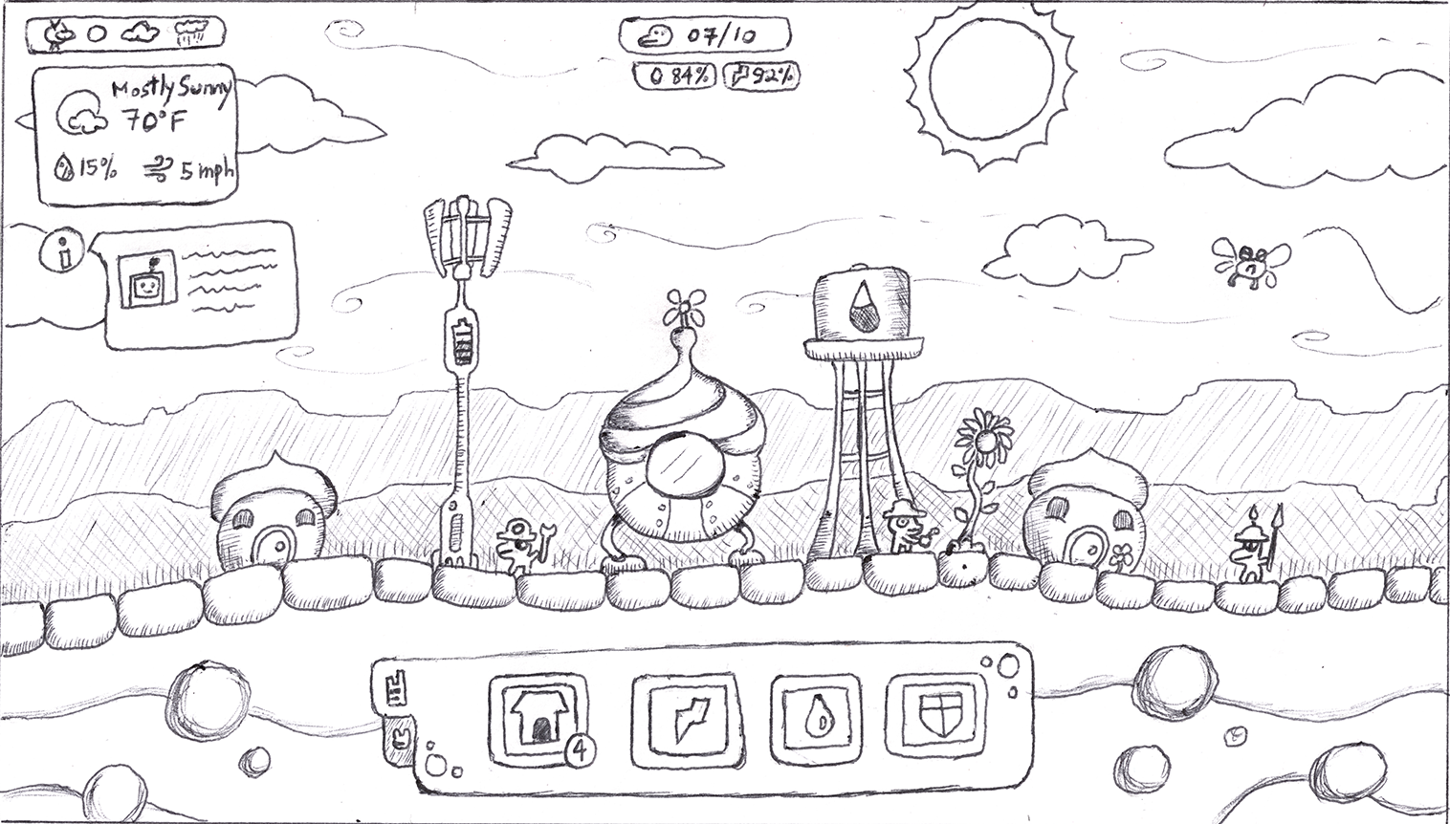

### Specialist Frogs

|  |  |  |
| --- | --- | --- |
|  |  |  |

# Schedule for Development + Delivery

These are rough estimates, and some tasks can overlap between art/design/tech.

* Projected coding time (prototype): 3-4 weeks. This will cover all gameplay features, but with placeholder art.
* Projected coding time (art/lesson/final design): 2-3 weeks. This covers art/animation implementation, lesson/narrative, gameplay tweaks.
* Projected design time: 1-2 weeks. Level designs in concert with coding the prototype.
* Projected lesson implementation time: 1-2 weeks. This includes animated illustrations, tutorials.
* Projected art time: 4-5 weeks. Congruent with coding time, along with implementing the overworld overlays and wind animation.

# Story / Narrative

### Back Story

Space frogs exiled from a faraway galaxy, looking for a new home. There won’t be any explicit explanation other than finding Earth as a new suitable habitation.

### Plot Elements

* Discovery of Earth
* Colonization of different regions for different groups of frogs.
* Paradise established at the end.